Week : 21  Period : 61 | UNIT 7 : TELEVISION  Lesson 7: Looking back and project | Date of preparing:  Date of teaching:
A. OBJECTIVES:
I. Knowledge: By the end of the leson, Ss will be able to
Consolidate and apply what students have learnt : Vocabulary, Grammar, Communication
II. Competencies: By the end of the leson, Ss will be able to
Put the words in the columns, complete the paragraph, complete the conversations
III. Character qualities:
Ss will be more aware of spending time watching TV, and choose the best programmes for themselves.
B. TEACHING AIDS
I. Teacher: Textbooks, computer accessed to the Internet, projector
II. Students: Textbooks, coloured chalk
C. PROCEDURE
I.Warm-up
* Aim:To help students revise the vocabulary items they have learnt in the unit.
“Brainstorming”
Cartoon
Television
TV viewer
Game show

Teacher divides the class into 2 big groups
Teacher asks students to brainstorm all programmes and the adjectives related to television
The group having the most suitable answer
II. Pre-stage
Aim:To help students revise programmes and the adjectives describing them
Task 1 Put the words in the box in the correct columns
+ Programmes: sport, wildlife, English in a minute
+ Adjective describing programmes:
educational, interesting, popular, funny
T asks students to put the words in the part “Warm-up” in the correct columns.
Task 2: Use the words in the box to complete the text
- Viewers 2 Animal3 Sports 4Funny5 Educational
- T asks Ss to do the task individually
III. During-stage
* Aims:To help students revise the use of question words.
Task 3 Use question words to make suitable questions below.
1. How many2. What3. Why4. Who5. How many
Ask Ss to look at the answers and underline the missing informatio.
Check their answers as a class.
Task 4:Connect sentences.
1. Ocean Life is on at 7.30 and Laughing out Loud comes next at 8.00.
2. I like The Seven Kitties very much, so I watch it everyday
3. BBC One is a British channel but VTV6 is Vietnamese channel.
4. Along The Coast is a famous TV series, but I don’t like it.
5. I have a lot of homework to do tonight, so I can’t watch Eight Feet Below.
Ask Ss to read the two sentences in each question and use the conjunctions provided to connect
Check their answers as a class
IV. Post-stage
Aims:To allow students to apply what they have learnt (vocabulary and grammar) into practice througha project.
Project
To this activity, Ss may go out and ask question to find out how important TV is to their friends, to take note of the answers, and to report the results to other people
V. Homework
Learn all the vocabulary/ grammar
Prepare for the next lesson: Unit 8

Feedback:…………………………………………………………………………………………………………………………………………………………………………………………………………..

Week : 21  Period : 63 | UNIT 8: SPORTS AND GAMES  Lesson 2: A closer look 1 | P: ……………..  T:……………..
I. Objectives:
1. Knowledge: By the end of this lesson, students will be able to
-Get some more lexical items related to topic “Sports and Games” and practise to pronunce the sounds /e / and /æ/.
2. Competences:
-Cover the content of the conversation about sports and games topic by using vocabularies and pronunciation the sound/e /and /æ/
3. Qualityies:
-Be more aware of spending time watching and practicing sports and games.
II.Teaching aids
Textbooks, plan, computer accessed to the Internet, projector, loudspeaker
III. Procedure
1: Warm-up
Aim: To attract Ss’ attention to the lesson and review some vocabulary related sports and games.
*Brainstorming
- Teacher divides the class into two teams. One member from each team, in turns, comes to the board and lists all the sports and games they have learnt.
- 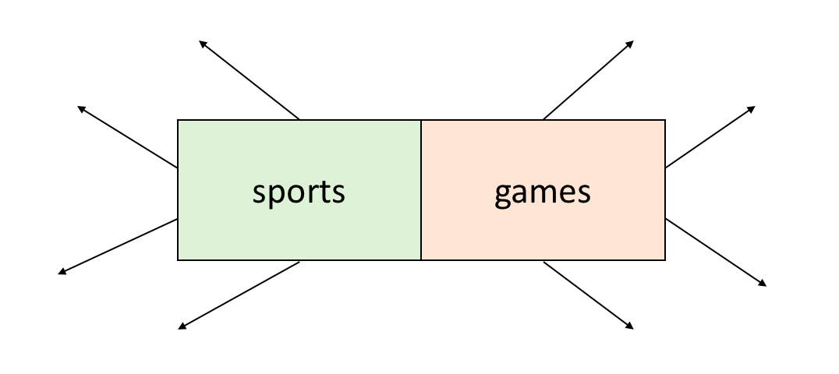
2. Pre-stage:
Pre teach Vocabulary
Aim: Ss can know to use some new words to describe about the topic.
-- Teacher use different techniques to teach vocabulary (situation, realia, …)

Vocabulary.
- racket (n)
- goggles (n)
- competition (n)
- champion (n)

- T asks Ss to listen and repeat the words.
3.During stage

Aim: -To revise/ teach the names of some sports/ games and the tools to be used with them .

Task 1: Write the words under the pictures ( Part 2 p. 18 )
-T also runs through the 8 pictures in part 2 p. 18.
- T gives the instruction: Write the words under the pictures
Picture 1. bicycle
- T checks Ss’ understanding.
Task 2: Matching (Part 3 p. 18)
T shows the poster on the board then runs through.
- T models one. 1.c
- T checks Ss’ understanding.
- Teacher checks with the whole class, asks students to give more names of sports and equipment to be used with them.
Task 3: Fill each blank with the words from the box. (To give students
-Teacher calls one student to write the words on the board, then gives correction.
- Feedback
Pronunciation
Aim: Ss candescribe about the topic “Sports and Games” and practise to pronunce the sounds /e /and /æ/in isolation in the context.
Pronunciation /e /and /æ/
- T models the sound /e /and /æ/
-Teacher plays the recording for students to check and repeat the sentences.(twice).

- Feedback

Task :Listen and repeat. Underline the words with the sound /e/ and /æ/

(Part 5p.1 8)

- T shows the popster which has the content of part 5 p. 18 then runs through.

- T asks Ss to read aloud the words and choose which one has /e /and /æ/

- T models one.

- T gets Ss’ answers then corrects.
4. Post-stage Tongue Twister
Aim: Help students use the knowledge they have learned to practice.

Tongue Twister

- T shows the poster which has the content of part 5 p. 18 then runs through.
- T models one

- T checks Ss’ understanding.

- T plays the record twice.

- T gets Ss’ answers then corrects
5. Homework/wrap:
- Learning by heart vocabulary and read again the sounds/e /and /æ/
- Seeing the newwords and the past simple tense in Unit 8: Lesson 3: A closer look 2
V. FEEDBACK:

