|  |  |  |
| --- | --- | --- |
| Week: 21  Period: 61 | **UNIT 7: LIFE IN THE COUNTRYSIDE**  **Lesson 7: Looking back and Project** | P: …./1/2024  T: …/1/2024 |

**A. OBJECTIVES**

By the end of this lesson, Ss will be able to:

**1. Knowledge**

- review the vocabulary and grammar of Unit 7

- apply what they have learnt (vocabulary and grammar) into practice through a project.

**2. Competences**

- Develop communication skills and creativity

- Be collaborative and supportive in pair work and teamwork

- Actively join in class activities

**3. Personal qualities**

- Love talking about activities to protect the enviroment

**B.TEACHING AIDS**

- Grade 8 textbook, Unit 7, Looking back and Projects

- Computer connected to the Internet

- TV/

**C. PROCEDURES**

**1. WARM-UP** (5 mins)

**Objectives:**

- To create an active atmosphere in the class before the lesson;

- To lead into the revision

**Revision**

- Teacher asks Ss to think of what they have learnt already in Unit 7.

- Ss work in pairs to do the task. Teacher calls some students to retell.

**2. VOCABULARY REVISION** (10 mins)

**a. Objectives:**

- To help Ss review the vocabulary of Unit 7

**Task 1: Choose the correct answer A, B, or C to complete each sentence.**

Task 1:

*1.A*

*2. C*

*3. B*

*4. A*

*5. C*

**Task 2: Complete each of the sentences with a word or phrase from the box.**

- For activities 1 and 2, have Ss do these activities individually then compare their answers with their partners.

- Go round and monitor the class, giving support if necessary

- Ask for Ss’ answers or ask some Ss to read out their answers in front of the class.

- Confirm the correct answers.

Task 2:

*1. littering*

*2. carbon footprint*

*3. picking up rubbish*

*4. habitats*

*5. endangered species*

**3. GRAMMAR** (12 mins)

**a. Objectives:**

- To help Ss revise complex sentences with adverb clauses of time;

- To help Ss practise writing sentences about themselves, using complex sentences with adverb clauses of time

- Ask Ss to do the exercise individually first. Then they can check their answers with a partner before discussing the answers as a class.

- Call on some Ss to write their answers on the board, other Ss give comments, and correct mistakes only when really necessary.

**Task 3. Complete the following sentences using a clause. Use your own ideas.** (5 mins)

**Task 4: Circle A, B, or C to identify the underlined part that needs correction** (5 mins)

***Suggested answers:***

***Task 3:***

***Task 4:***

*1. A 2. B 3. C 4. C 5. B*

**4. PROJECT (14 mins)**

**a. Objectives:**

- To give Ss an opportunity to practise finding solutions to a serious environmental problem in their area;

- To improve their speaking and presentation skills.

**A serious pollution problem in my area**

- Make sure Ss understand what to do. Ask Ss to work in groups and decide on the most serious pollution problem in their area (noise pollution, air pollution, water pollution, …). Then find as many solutions to the problem as possible.

- Teacher asks Ss to work in groups and make a poster to introduce the solutions they have suggested. Encourage them to use a mind map to make their poster easier to understand. Tell them they can use pictures, images, etc.

- Call on some groups to show their posters and make a presentation. Other groups give their comments. The class votes for the best poster.

Task P1: Choose a serious pollution problem in your area (noise pollution, air pollution, water pollution, …). Suggest solutions to the problem.

Task P2: Make a poster. Write your solutions on the poster. Use pictures to illustrate / decorate your poster.

Task P3: Present your poster to the class.

**Suggested outcome:**

*Students’ posters & presentations*

**6. CONSOLIDATION**

**a. Wrap-up**

- Summarise the main points of the lesson.

**b. Homework**

- Students’ workbook

**\* FEEDBACK:**

|  |  |  |
| --- | --- | --- |
| Week: 21  Period: 62 | **UNIT 8: SHOPPING**  **Lesson 1: Getting started**  **My favourite shopping place** | P: …./2/2024  T: …/2/2024 |

**A. OBJECTIVES**

By the end of this lesson, Ss will be able to:

**I. Knowledge**

- Gain an overview about the topic *Shopping*

- Gain vocabulary to talk about shopping

**II. Core competences**

- Develop communication skills and creativity

- Be collaborative and supportive in pair work and teamwork

- Actively join in class activities

**III. Personal qualities**

- Show interest in and respect for different types of shopping places

**B.TEACHING AIDS**

- Grade 8 textbook, Unit 8, Getting started

- Computer connected to the Internet

- Projector / TV

- *hoclieu.vn*

**C. PROCEDURES**

**I. WARM-UP**

**Aims:**

+ To create an active atmosphere in the class before the lesson;

+ To lead into the new unit.

**CHATTING**

- T asks ss some questions about the topic:

*1. Do you like shopping?*

*2. Where do you often go shopping?*

*3. Can you name some markets or supermarkets that you know?*

*4. Do you prefer shopping in an open-air market or in a supermarket?*

- T leads to the new unit. Write the unit title SHOPPING on the board. Ask Ss to guess what they are going to learn about in this unit.

**II. PRE-STAGE**

**Aims: +** To present Sts necessary lexical items related to the topic “Shopping”

+ To help Ss learn words and phrases related to different markets and their features;

**Vocabulary:**

- T elicits words from students

1. open-air market (n)chợ họp ngoài trời

2. home-grown (adj)tự trồng

3. home-made (adj)

4. bargain (v)mặc cả

5. farmers’ market (n)chợ nông sản

6. price tag (n)nhãn ghi giá mặt hàng

7. convenience store (n)cửa hàng tiện lợi

- T models -Ss-repeat

- T writes down-Ss copy

* Checking vocab: R.O.R

**Task 1: Listen and read**

- Teacher has Ss to look at the pictures in the book and answer the questions.

- *What do you think Mai and Alice are talking about?*

*- What are the pictures about?*

*- What are the people in the pictures doing?*

- Teacher plays the recording for ss to listen and read along. Then invite some pairs of Ss to read the conversation aloud.

- T refers to the questions previously asked and confirms the correct answer.

***Suggested answer:***

- Mai and Alice are talking about different types of markets.

- The pictures are about Bac Ha Open-air Market.

- The people in the picture are buying and selling things.

**III. DURING STAGE**

**Aims:** + To help Ss read for specific information about markets.

+ To help Ss learn words and phrases related to different markets and their features;

+ To help Ss further understand the text.

**Task 2: Mai and Alice mentioned four places where they can buy things. Complete the list.**

- Encourage ss to do the task without reading the conversation again. If they can’t, let them refer to the conversation for the answers.

- Teacher checks the answers as a class and gives feedback.

***Answer key:***

1. open-air market

2. farmers’ market

3. supermarket

4. convenience store

**Task 3: Match the types of markets with the features.**

- Ask Ss to look at the two types of markets first and see if they can remember any information about them from the conversation. Encourage them to say it.

- Ask ss to do the task individually or in pairs.

- Ask Ss to say the words / phrases aloud. Make sure they pronounce the words and phrases correctly.

- Teacher checks the answers as a class and gives feedback.

***Answer key:***

1. a, c

2. b, d, e

**Task 4: Complete the sentences with the words and phrases from the box.**

- Call on some ss to read the words and phrases in the box aloud. Correct their pronunciation if needed.

- Ask ss to work independently to fill each blank with a word or phrase from the box.

- Check the answers as a class.

***Answer key:***1. bargain 2. convenience store 3. home-grown

4. price tag 5. home-made

**IV. POST STAGE**

**Aims:** + To introduce various types of speciality shops.

+ To create a fun atmosphere in the class.

**Task 5: GAME: Listing**

**Work in groups. Quickly write down the names of some speciality shops. The group with the most correct answers wins.**

- To lead in, write the words “music shop” and “sports shop” on the board. Ask Ss what they can buy from each shop. Then write the word “speciality shops” above the two shops.

- Allow Ss some time to write down the names of as many speciality shops as possible.

- Call on some Ss to read aloud their list. Find the Ss with the most correct answers.

***Suggested answer*:**

clothes shop, florist’s, bakery, butcher’s, bookshop, greengrocer’s, stationer’s, dairy, candy shop, café, music shop, computer shop, barber’s, hairdresser’s, gift shop, pet shop, shoe shop, etc.

**V. WRAP- UP**

**Aim:** To consolidate what students have learnt in the lesson

- Ask Ss to name some shops they have learnt in the lesson.

- If there is an overhead projector in the classroom, show the dialogue, highlight the key words related to the topic.

**VI. HOMEWORK**

- Name some places for shopping they have learnt about in the lesson.

- Learn new words and phrases by heart.

- Learn vocabulary by heart.

- Do the exercise in workbook: Ex 1/p52

- Prepare lesson: A closer look 1

**VII. FEEDBACK:**

………………………………………………………………………………

|  |  |  |
| --- | --- | --- |
| Week: 21  Period: 63 | **UNIT 8: SHOPPING**  **Lesson 2: A closer look 1** | P: …./2/2024  T: …./2/2024 |

**A. OBJECTIVES**

By the end of this lesson, Ss will be able to:

**I. Knowledge**

- Identify some nouns related to the topic of shopping, some types of shops and their characteristics as well.

- Distinguish two consonant blends /sp/and */*st*/*

**II. Core competences**

- Developcompetencies of communication, cooperation, and self-management.

- Be collaborative and supportive in pair work and teamwork

- Actively join in class activities

**III. Personal qualities**

- Raise ss’ awareness of responsible shopping and have good attitude to shopping

**B.TEACHING AIDS**

- Grade 8 textbook, Unit 8, A closer look 1.

- Computer connected to the Internet

- Projector / TV

- *hoclieu.vn*

**C. PROCEDURES**

**I. WARM-UP**

**Aim:**To create an active atmosphere in the class before the lesson;

**Game: Video watching**

- Give Ss a few minutes to watch a video and ask ss some questions about the clip.

- T leads in the new lesson.

***Video link:*** [*https://www.youtube.com/watch?v=d-jE5WJ7J28*](https://www.youtube.com/watch?v=d-jE5WJ7J28%5C)

***Suggested questions:***

**-** Do you know the film? What is its name? (Confession of a shopaholic)

- What is the film about? (It’s about a girl who is addicted to shopping)

**II. PRE-STAGE**

**Aim:** + To visually introduce some nouns/ words related to the topic of shopping.

**Vocabulary:**

- T elicits words from students

1. shopaholic (n)người nghiện mua sắm

2. on sale đang (được bán) hạ giá

3. discount shop (n)cửa hàng hạ giá

- T models -Ss-repeat

- T writes down-Ss copy

* Checking vocab: R.O.R

**Task 1: Listen and read**

**Write the words and phrases under the correct pictures.**

- Ask Ss to read the words and phrases, then look at the pictures and do the task.

- Check the answers as a class.

- Have Ss then read the words and phrases aloud. Correct their pronunciation if needed.

- If necessary, ask Ss for the Vietnamese equivalents of these words and phrases.

***Answer key:***

1. price tag 2. shopaholic 3. on sale4. browsing 5. Internet access

**III. DURING STAGE**

**Aims:** +To introduce more types of shops and their characteristics.

+To provide ss with an opportunity to use some vocabulary in sentences

+ To help sts identify how to pronounce the sounds /sp/ and /st/

+ To help Ss practise pronouncing the sounds /sp/ and /st/ correctly in words and sentences

**Task 2: Match the shopping places with their characteristics.**

- Ask Ss to read the names of different places for shopping and see if they know any of their characteristics.

- Allow Ss some time to do the matching.

- Call on some Ss to give their answers.

- Check the answers as a class.

***Answer key:***1. e 2. a 3. d 4. b 5. c

**Task 3: Complete the sentences with the words and phrases from the box.**

- Ask Ss to read the words and phrases provided.

- Ask Ss to work individually.

- Call on some Ss to say their answers.

- Check Ss’ answers as a class.

- T can also ask some Ss to read out their answers. Then have Ss read the sentences aloud as a class. Correct  Ss’ pronunciation if necessary.

***Answer key:***

1. speciality shops 2. browsing 3. bargain 4. range of products 5. shopaholic

**Task 4: Listen and repeat the words. Pay attention to the sounds /sp/ and /st/**

- Have some Ss read out the words. Correct them if needed.

- Play the recording for them to listen and repeat the words as a class, in groups, and individually. - Play the recording as many times as necessary

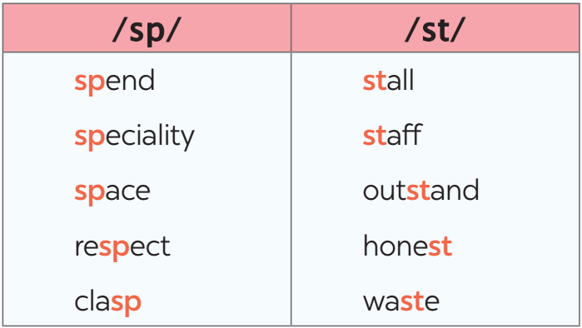

**Task 5: Listen and repeat the sentences. Pay attention to the underlined words**

- Have Ss read the sentences, paying attention to the underlined words with the sounds /sp/ and /st/.

- Play the recording for Ss to listen and repeat each sentence. Correct them if needed

- Call some Ss to read the sentences individually. Correct them if needed

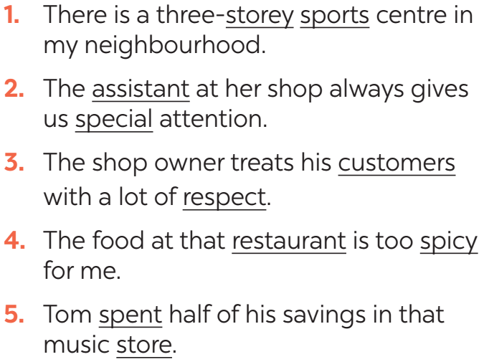

**IV. POST-STAGE:**

**Aim. Objectives:**

- To test students' quick reaction to the targeted sounds

**Game: Whispering**

- Teacher explains the rule:

RULE:

+ Work in 2 teams

+ Players stand in a line.

+ The teacher whispers 5 words one by one from one person to the next until it gets to the end of the line. The last person in the line repeats the words.

+ The team with more correct words will win.

**V. WRAP-UP**

**Aim**: To consolidate what sts have learnt in the lesson

- Ask Ss to summarise what they have learned in the lesson.

- Ask them to list some nouns related to shopping learned in the lesson.

- Ask them to list some shopping places and characteristics

- Ask ss to give 2 sounds learned in the lessons and give examples.

**VI. HOMEWORK**

- Name a list of shopping places

- Find 5 more words with the sounds /st/ and /sp/

- Do exercise in the Workbook: Ex 1,2/p52

- Prepare for the next lesson: Unit 2: Closer look 2.

**VII. FEEDBACK:**

………………………………………………………………………………