|  |  |  |
| --- | --- | --- |
| Week 19  Period 55 | UNIT 7 : TELEVISION **Lesson 1: Getting Started** | **Date of preparing:14/01/2024**  **Date of teaching: 16/01/2024** |

**A. OBJECTIVES:**

**I. Knowledge:** By the end of the lesson, students can: Have an overview of the topic “Television”- Practice listening, reading and speaking with the lexical items

**II. Competencies:**  Ss will be able to Match, find the adjectives describing in the conversation.

**III.Character qualities**:Ss will be more aware of spending time watching TV.

**B. TEACHING AIDS**

**1. Teacher:** Textbooks, computer accessed to the Internet, projector

**2. Students:** Textbooks, pen, ……

**C. PROCEDURE**

**I. Warm up (5’)**

\***Aim:** To attract Ss’ attention to the lesson and introduce the topic to lead in the lesson

**Show a picture and ask Ss to look at the title of the conversation and the picture. Ask them some questions:**



T: What do you think they are talking about?

S: They are talking about their favourite TV programmes

T: What TV programmes do you like best?

S: I like watching cartoons best**..**

**II. Pre-stage**

**\* Aim:**To prepare students with vocabulary related to the topic Television;

**. Listen and read.**

**\* Vocabulary**

**-** programme (n): chương trình

- channel (n): kênh

- educational (adj): mang tính giáo dục

- animated film (np): phim hoạt hình

- talent(n): tài năng

- to prefer: thích

- Follow the seven steps of teaching vocabs

**III. During stage**

**\* Aim** To introduce the topic of the unit ,the vocabulary, the grammar points .

**Task 1: Listen and read.**

Teacher plays the recording twice.

* Students listen and read

**Task 2**

**2. Choose the correct answer A, B or C**

1. C2. A 3. A 4. A

T asks students to read the conversation again and choose the correct answers

**Task 3**

**3. Read the conversation and match 1-5 with a-e**

1. c 2. a 3. e 4. B 5. d

Students read the conversation again to match 1-5 with a-e, check their mate’s answer.

**Task 4**

**4. Find and write the adjective in the conversation which describe the programmes and characters below**

1. interesting2. Wonderful3. Clever4.educational

**IV. Post-stage**

**Aim:**To give students apply in real life and talk about things they like about television

Eg: In our group, Mai likes sports programme on TV. Binh likes ………

**Step 1:**

T asks students to work in groups of 4 to ask and answer about their favourite TV programmes

**Step 2**: reports

T asks Ss to share their answers and report to the class

**V . Homework**

Write things you like about television and the reason

Prepare the lesson: Unit 7: A closer look 1

**\*Feedback:** ……………………………………………………………………………………………

………………………………………………………………………………………………

|  |  |  |
| --- | --- | --- |
| Week 19  Period 56 | **UNIT 7 : TELEVISION**  Lesson 2 : A **closer look 1** | Date of preparing: 14/01/2024  Date of teaching: 16/01/2024 |

**A. OBJECTIVES:**

**I. Knowledge:** By the end of the lesson ss will be able to:

Learn and practice using vocabulary/phrases related to the topic “Television”

Learn more adjectives to describe television programmers and characters

Identify how to pronounce the sounds /θ/ and /ð/ and practice.

**II. Competencies:** Ss will be able to Write the words/phrase next to the definition, complete the sentences, listen to the words.

**III. Character qualities:**Ss will be more aware of spending time watching TV

**B. TEACHING AIDS**

**I. Teacher:** Textbooks, computer accessed to the Internet, projector

**II. Students:** Textbooks

**C. PROCEDURE**

**I. Warm up**

* **Aim:** To attract Ss’ attention to the lesson and review some programs on TV

Teacher sticks 6 pictures and 6 words on the board.Students work in 2groups

Teacher asks students to go to the board to stick each word with its correct picture.

The group with more correct answers will be the winner.

**II. Pre-stage**

**\* Aim:**To enrich students’ vocabulary related to TV topic

**\* Vocabulary**

**.** cute(adj): dễthương

**.** comedy(n): hàikịch

**.** viewer(n): ngườixem truyên hình

**.** to laugh: cười

**.** popular (adj): phổbiến

- Use different techniques to teach vocab (pictures, situation, realia)

- Follow the seven steps of teaching vocab.

**III. During-stage**

**\* Aims:** To revise / introduce some words relatedto TV topic

- To give Ss further practice in using TV show-related words/phrases in context.

**Task 1.Write the words/ phrases next to the definitions**

T asks Ss to read the words/ phrases in the box first.

**Task 2: Complete the sentences with the words/phrases in the box**

1. channel 2. Character 3. Animated 4. game show 5. Comedies 6. viewer

T asks Ss to read the sentences carefully and choose the correct words/ phrases to complete

T checks their answer as a class

**Task 3**

Teacher asks students to work independently and put a suitable word in each blank.

Teacher allows students to share their answers before discussing as a class.

**Task 4**:  **Listen and repeat the words**

Teacher introduces 2 sounds /***ө***/ and /**ð/**

T asks Ss to read the words first as they are familiar with Ss

T plays the recording;S listen and repeat the word

**IV. Post-stage**

* **Aim:**To help students pronounce the sounds /***ө***/ and /**ð/** correctly in context.

**5.Tongue Twister**

***\* Game: Who is faster?***

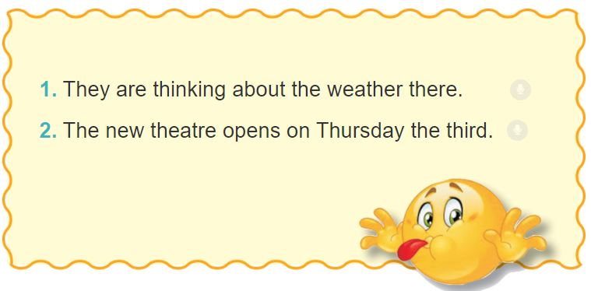

**V. Homework**

- Rewrite the sentences into notebooks.

- Prepare lesson 3 ( A closer look 2)*.*

**\*Feedback**

…………………………………………………………………………………………………………………………………………………………………………………………

|  |  |  |
| --- | --- | --- |
| Week 19  Period 57: | UNIT 7 : TELEVISION Lesson 3 : **A closer look 2** | Date of preparing: 14/01/2024  Date of teaching: 17/01/2024 |

**A. OBJECTIVES:**

**I. Knowledge:**Identify the functions of different questions words and practice with them

Know the meanings as well as the use of the three conjunctions to make compound sentences.

**II. Competencies: Ss will be able to complete sentences, complete the conversation.**

**III. Character qualities:**Ss will be more aware of spending time watching TV.

**B.TEACHING AIDS**

**I. Teacher:** Textbooks, computer accessed to the Internet, projector

**II. Students:** Textbooks, coloured chalk

**C. PROCEDURE:**

**I. Warm up**\***Aim:** To remind Ss some words/ phrases related to TV programmes

**1. Play game: Guess words**

1/ What programme is “Children are always right” -> Game show

2/ What programme makes us laugh? ->Comedy

3/ What programme teaches us many subjects? ->Educational programme

**Play game: Guess words**

T calls one student read a description aloud. The other students try to guess what word it is.

**II. Pre-stage**

To remind Ss some question words they are familiar with and lead in the lesson

**2. Questions words**



1/ What is the name of the film?2/ What time is it on?

3/ How often is it on? 4/ When is it on?

5/ How many main characters are there in the film?6/ What channel is it on?

**QUESTION WORDS**

Ask Ss to look at the picture and answer the questions

**III. During-stage**

**Aim:**To help students remind more questions they are familiar with

To help students know and identify the functions of different wh/h- question

**Task 1: Underline the question words**

What are you doing tomorrow?

Where is it?

How long is it on?

T asks Ss to read the conversation and underline the question words

**Task 2:Match the question word with the information**

T allows Ss to read and do the matching individually or in pair

T plays the recording. T asks Ss to listen and check their answers.

**IV. Post stagAims:-** To help students practice more with question wordsand use of the three conjunctions: but, so, and

T asks students to use the question word to complete

**Task 4: Match the beginnings with the endings**

1. C, 2A, 3E, 4B, 5D

Ss work in individually or in pair-Ss read the complete sentences out loud

**Task 5:Complete the sentences**

1.so 2. but 3. so 4. but 5 .and.

Ss work individually or in pair. They can exchange and check the answer.

**+ Consolidation**

Conjunction,Wh/h-question

Teacher asks students to talk about what they have learnt in the lesson

**V.Homework**

Make sentences with Wh-questions and Conjunctions

**\*. Feedback :**…………………………………………………………………………………

…………………………………………………………………………………………….