Week: 25  Period: 73 | UNIT 9: NATURAL DISASTERS  Lesson 5: Skills 1 | P: 10/3 / 2024  T: 11 / 3/ 2024
A. OBJECTIVES
By the end of this lesson, Ss will be able to:
1. Knowledge:
- Use the lexical items related to natural disasters.
- Further understand about natural disasters through the two articles.
- Prepare a short piece of news about natural disasters.
2. Core competence:
- Develop communication skills and creativity.
- Be collaborative and supportive in pair work and teamwork.
- Actively join in class activities.
3. Personal qualities:
- Develop awareness of Natural disasters.
- Be concerned to Natural disasters.
B.TEACHING AIDS
- Grade 8 textbook, Unit 9, Skills 1
- Computer connected to the Internet
- Projector / TV
- hoclieu.vn
C. PROCEDURES
I. WARM-UP
Aims: - To create an active atmosphere in the class before the lesson.
- To lead into the new lesson.
Who’s faster?
- Teacher divides Ss into groups.
- Teacher gives each group a piece of paper.
- Teacher asks them to list all the words about natural disasters they have learnt.
- Ss work in their group and list all the words about natural disasters in 2 minutes.
- Teacher asks 4 groups to ticks their posters on the board.
- Teacher checks and gives comments.
- The group with most correct words is the winner.
erupt
Natural disasters
II. PRE-STAGE: READING
Aims: - To introduce the new words related to natural disasters.
- To help Ss understand more clearly the meaning of some words.
- To help Ss use the words in specific contexts.
Vocabulary pre-teaching
Vocabulary:
- Teacher introduces the vocabulary.
- Teacher explains the meaning of the new vocabulary, using pictures and translation.
New words:
1. Ash (n)
2. Tsunami (n)
3. Tremble (v)
- Teacher reveals that the words according to the pictures will appear in the reading text and asks students to open their textbook to find these words
- Teacher introduces the vocabulary.
- Teacher checks students’ understanding with the “Matching” technique.
III. DURING-STAGE:
Aims: - To activate Ss’ knowledge of the topic of the reading text.
- To help Ss develop the skill of guessing the meaning of new words in context.
- To help Ss develop the skill of reading for specific information.
Task 1. Match the headlines (1 – 2) with the natural disasters (A – B). (5 mins)
- Teacher asks Ss to read the headlines carefully and match them with the disasters.
- Ss work individually and do the task.
- Teacher elicits and confirms the correct answers.
- Teacher tell Ss something about Tonga which is a country in the South-western Pacific Ocean. It consists of about 170 islands.
- Teacher tells them that they are going to read news articles about two natural disasters.
Answer key:
1. B
2. A
Task 2. Read the two news articles. Match the highlighted words with their meanings.(7 mins)
- Teacher asks Ss to read through the two articles individually.
- Ss read the articles carefully and match the words with their meanings.
- Teacher asks Ss compare answers in pairs.
- Teacher confirms the answers as a class and explains if needed.
Answer key:
1. d
2. e
3. a
4. b
5. c
Task 3. Read the articles again and answer the questions. (7 mins)
- Teacher asks Ss to work individually.
- Ss read the articles again and answer 5 questions.
- Teacher asks Ss to compare their answers with a partner.
- Teacher gets feedback.
- Teacher confirms the correct answer as a class.
Answer key:
1. In the South Pacific last Saturday.
2. A tsunami.
3. It destroyed hundreds of homes on some small islands, and more than twenty people on these islands are missing.
4. For about 30 seconds.
5. A strong earthquake in China.
V. POST-STAGE: SPEAKING (15 mins)
Aims: - To help Ss generate ideas for talking about a natural disaster.
- To help Ss practise asking and answering about a natural disaster.
- To give Ss a chance to give a short piece of news about a natural disaster.
Task 4. Work in pairs. Match the questions with the answers. (6 mins)
- Teacher asks Ss to work in pairs.
- Ss read all the sentences carefully then match the questions with suitable answers.
- Teacher moves around to observe and offer help if needed.
- Teacher invites some pairs to practise in front of the class.
Answer key:
1. c
2. e
3. a
4. b
5. d
Task 5. Work in groups. Prepare a short piece of news about the natural disaster in 4 or one you know of. Report the news to the class. (7 mins)
- Teacher divides Ss into groups.
- Ss prepare a short piece of news about natural disasters.
- Teacher asks them to read the news in the reading part again to imitate the way to write news.
- Teacher asks them to read the example. Teacher tells them that they only need to organise the answers to the questions in 4 in a logical order to create a piece of news.
- Teacher moves around to give support if needed.
- Teacher invites some groups to report the news to the class.
- Teacher asks other groups to listen and give comments.
- Teacher cmments on Ss’ answers.
Example:
Five days of heavy rain caused a serious flood in a village in Phu Yen. The flood happened last week. …
V.WRAP-UP:
Aim: To consolidate what Ss have learnt in the lesson.
- Summarise the main points of the lesson.
VI. HOMEWORK:
- T asks Ss to practice talking about natural disasters
- Do the exercises part READING in the Workbook.
- Be ready for Skill 2
VII. FEEDBACK:
………………………………………………………………………………

Week : 25  Period : 74 | UNIT 9: NATURAL DISASTERS  Lesson 6: Skills 2 | P : 10 / 3 / 2024  T : 14 / 3 / 2024

A. OBJECTIVES
By the end of this lesson, Ss will be able to:
1. Knowledge:
- Use the lexical items related to the topic of the listening text.
- Develop the skills of listening for specific information.
- Write instructions about things to do before, during, and after a flood.
2. Core competence:
- Develop communication skills and creativity.
- Be collaborative and supportive in pairwork.
- Actively join in class activities.
3. Personal qualities
- Develop awareness of Natural disasters.
- Be concerned to Natural disasters.
B.TEACHING AIDS
- Grade 8 textbook, Unit 9, Skills 2
- Computer connected to the Internet
- Projector / TV
- hoclieu.vn
C. PROCEDURES
I. WARM-UP
Aims: - To create an active atmosphere in the class before the lesson.
- To lead into the new lesson.
Chatting: What should people do before, during and after a storm?
- Teacher shows a picture of a storm and asks Ss what people should do before, during and after a storm.  - Teacher asks Ss to work individually and think of the answers.  - Teacher invites some Ss to share their ideas.  - Teacher give comments and leads to the new lesson. | 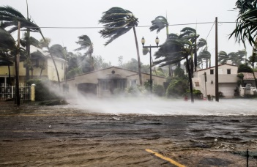
II. PRE- STAGE: PRE-LISTENING
Aim: - To introduce the new words related to natural disasters.
- To help Ss understand more clearly the meaning of some words.
- To help Ss use the words in specific contexts.
- To prepare Ss for the listening text.
- To help Ss develop the skill of listening for specific information.
Vocabulary:  - Teacher introduces the vocabulary.  - Teacher explains the meaning of the new vocabulary, using pictures and translation.  - Teacher checks students’ understanding with the “Matching” technique. | New words:  1. Authority (n)  2. Warn (v)  3. Avoid (v)
III. DURING- STAGE
Aim: To help Ss develop their skill of listening for specific information.
Task 1. Work in pairs. Look at the picture and answer the questions. (4 mins)
- Teacher asks Ss to work in pairs and look at the pictures carefully.
- Ss look at the pictures and answer the two questions.
- Teacher elicits the answers from Ss.
- Teacher invites some Ss to answer in front of the class.
Suggested answer:
A torch, a mask, a lamp, a whistle, a bottle of water, some medicine, matches, a radio, some plasters, a candle, a multi-purpose knife, some batteries, a blanket.
Task 2. Listen to a broadcast. Put the activities (1 – 6) in the correct column. (7 mins)
- Teacher tells Ss that they are going to listen to a broadcast in which instructions to prepare for a natural disaster are given.
- Teacher has them read the activities 1-6 and try to guess which activities go into which column.
- Teacher invites some Ss to share their answers and write them on the board.
- Teacher has Ss read the activities again and underline the key words.
- Teacher plays the recording and asks Ss to listen and put the activities in the correct columns.
- Ss work in pairs to compare their answers.
- Teacher asks for Ss’ answers and compare them with the ones on the board.
- Teacher confirms whether they are right or wrong, playing the audio again if necessary.
Answer key:
+) Before a storm: 2,6
+) During a storm: 3,5
+) After a storm: 1,4
Task 3. Listen again and tick (√) T (True) or F (False) for each sentence. (7 mins)
- Teacher tells Ss that they are going to listen to the broadcast again and decide if the statements are true or false.
- Without playing the recording again, teacher has Ss read the statements and decide if they are true or false.
- Teacher plays the recording and asks Ss to listen again to check their answers.
- Teacher asks Ss to work in pairs to compare their answers.
- Teacher asks for Ss’ answers and confirms the correct ones.
Answer key:
1. F
2. T
3. F
4. T
IV. POST- STAGE: WRITING
Aims: - To brainstorm ideas and make an outline for Ss’ writing.
- To help Ss practice writing instructions about things to do before, during and after a flood.
Task 4. Work in pairs. Discuss what you should do before, during, and after a flood. Write your ideas in the columns. (5 mins)
- Teacher asks Ss to work in pairs.  - Ss discuss what they should do before, during and after a flood.  - Ss write their ideas in the columns.  - Teacher has some Ss present their ideas.  - Teacher comments on their answers. | 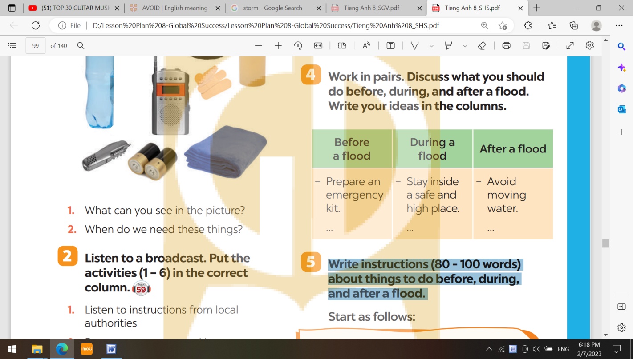
Task 5. Write instructions (80 - 100 words) about things to do before, during, and after a flood. (10 mins)
- Teacher asks Ss to work individually and write their instructions based on their answers in task 4.  - Teacher asks one student to write his/ her answer on the board. Other Ss and teacher comment on the writing on the board. | 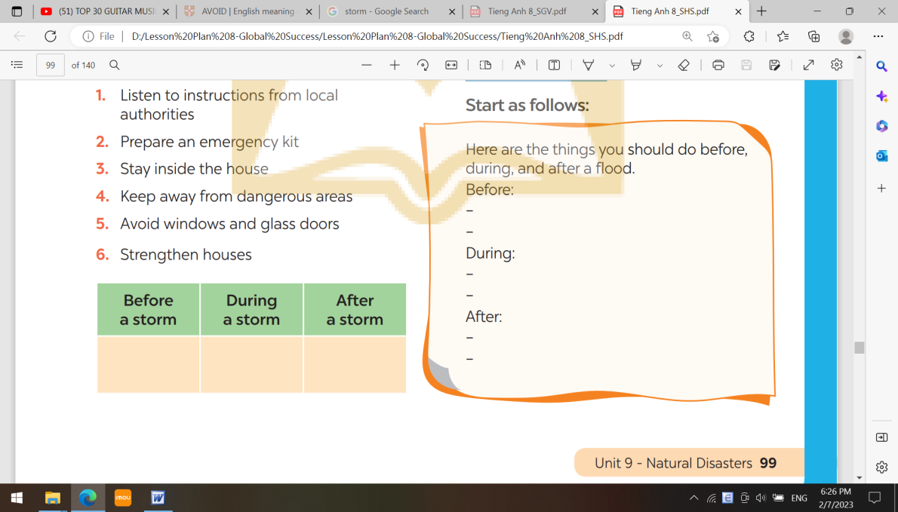
Suggestion outcome:
Here a things you should do before, during and after a flood.
Before:
- Build an emergency kit and make a family communications plan.
- Avoid building in a floodplain unless you elevate and reinforce your home.
- Elevate the furnace, water heater and electric panel in your home if you live in an area that has a high flood risk.
- Consider installing "check valves" to prevent flood water from backing up into the drains of your home.
- If feasible, construct barriers to stop floodwater from entering the building and seal walls in basements with waterproofing compounds.
During:
- Listen to the radio or television for information.
- Be aware that flash flooding can occur. If there is any possibility of a flash flood, move immediately to higher ground. Do not wait for instructions to move.
- Be aware of stream, drainage channels, canyons and other areas known to flood suddenly. Flash floods can occur in these areas with or without typical warnings such as rain clouds or heavy rain.
After:
- Avoid moving water.
- Stay away from damaged areas unless your assistance has been specifically requested by police, fire, or relief organization.
- Emergency workers will be assisting people in flooded areas. You can help them by staying off the roads and out of the way.
- Play it safe. Additional flooding or flash floods can occur. Listen for local warnings and information. If your car stalls in rapidly rising waters, get out immediately and climb to higher ground.
- Return home only when authorities indicate it is safe.
V. WRAP-UP:
Aim: To consolidate what Ss have learnt in the lesson.
- Ask Ss to summarize what they have learnt in the lesson.
VI. HOMEWORK:
- Rewrite the paragraph in the notebooks.
- Prepare for the looking back and project.
- Do the exercises part WRITING in the Workbook.
VII. FEEDBACK:
……………………………………………………………………………………………

Week : 25  Period :75 | UNIT 9: NATURAL DISASTERS  Lesson 7: Looking back and Project | P : 10 /3 / 2024  T : 16/ 3 / 2024

A. OBJECTIVES
By the end of this lesson, Ss will be able to:
1. Knowledge:
- Revise more vocabulary items they have learnt in the unit.
- Revise the differences between the past simple and past continuous.
- Revise the past continuous.
- Have an opportunity to research more deeply into a natural disaster.
2. Core competence:
- Develop communication skills and creativity.
- Be collaborative and supportive in pair work.
- Actively join in class activities
3. Personal qualities
- Develop awareness of Natural disasters.
- Be concerned to Natural disasters.
B.TEACHING AIDS
- Grade 8 textbook, Unit 9, Looking back and Project
- Computer connected to the Internet
- Projector / TV
- hoclieu.vn
C. PROCEDURES
I. WARM-UP
Aims: - To create an active atmosphere in the class before the lesson.
- To lead into the new lesson.
Mind Map
- Teacher writes on the board “Unit 9” and asks students to think of what they have already learnt in this unit.  - Students work in groups to do the task.  - Teacher calls some students to retell.  - Teacher confirms and leads them to do all the exercises in books. | 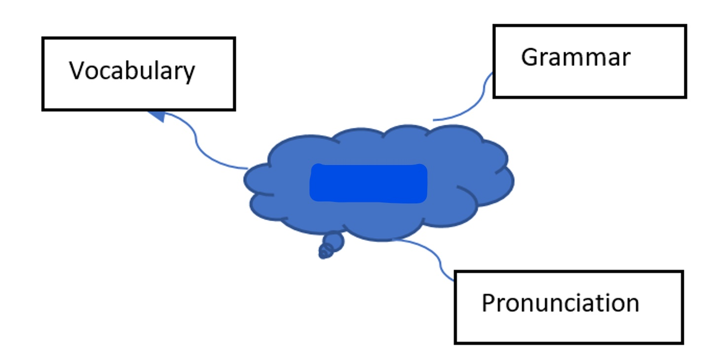  Unit 9  Unit 4  Vocabulary  Grammar  Pronunciation  Unit 4  Vocabulary  Grammar  Pronunciation  Unit 4  Vocabulary  Grammar  Pronunciation  Unit 4  Vocabulary  Grammar  Pronunciation
II. PRE-STAGE
VOCABULARY
Aim: To help Ss revise the vocabulary items they have learnt in the unit.
Task 1. Write the name of a natural disaster in each blank. (6 mins)
- Teacher asks Ss to work individually, read the sentences and look at the pictures.
- Ss write the name of a natural disaster in each blank.
- Teacher asks Ss to compare their answers with a partner.
- Teacher calls some Ss to share their answers.
- Teacher confirms the correct answers as a class.
Answer key:
1. flood
2. storm
3. earthquake
4. volcanic eruption
5. landslide
Task 2. Fill in each blank with the correct form of the word in brackets. (7 mins)
- Teacher asks Ss to work individually and read 5 sentences carefully.
- Ss complete the sentences using the correct form of the words given.
- Teacher asks Ss to share their answers with a partner.
- Teacher invites some Ss to write their answers on the board.
- Teacher confirms the correct answers.
Answer key:
1. destruction
2. predictions
3. victims
4. warned
5. workers
III. DURING-STAGE: GRAMMAR
Aim: - To help Ss revise the differences between the past simple and past continuous.
- To help Ss revise the past continuous by completing the sentences about them and their family members.
Task 3. Put the verbs into the correct tense: the past simple or past continuous. (6 mins)
- Teacher asks Ss to work individually and read the sentences carefully.
- Ss give correct form of the verbs (the simple past or past continuous).
- Teacher asks them to compare their answers with a partner.
- Teacher confirms the correct answers as a class.
Answer key:
1. were … doing
2. destroyed
3. was watering; came
4. were calling; appeared
5. Were … listening
Task 4. Complete the sentences about you and your family members. (8 mins)
- Teacher asks Ss to work individually and write sentences about their family members, using the past continuous.
- Teacher asks Ss to compare their sentences with a partner.
- Teacher invites some Ss to write their sentences on the board.
- Teacher comments on their answers.
Answer key:
1. I was doing my homework.
2. my grandmother / grandfather was watching TV.
3. my mother was reading a book.
4. my father was drinking a tea.
5. my sister / brother was washing dishes.
IV. POST –STAGE: PROJECT
Aim: To provide Ss with an opportunity to research more deeply into a natural disaster.
- Teacher asks Ss to read the instructions and makes sure they understand what to do.
- Teacher asks Ss to work in groups to do the project.
- Teacher instructs Ss how to carry out this project and asks them to try to search for information to answer the questions given and create a poster about the natural disaster they have chosen.
- Teacher asks Ss to present their poster to the class.
Task 1: Choose a natural disaster you want to learn more about.
- Teacher has students work in groups and choose natural disaster
Task 2: Create a poster about this natural disaster. Draw pictures or find suitable photos for it.
- Teacher shows some questions to guide sts:
What causes it?
- Where and when does it usually happen?
- What effects can it have?
- What should people do before, during, and after it happens?
Task 3: Present your poster to the class.
V. WRAP-UP:
Aim: To consolidate what students have learnt in the lesson.
- Teacher asks students to talk about what they have learnt in the lesson
VI. HOMEWORK:
- To review the whole unit 9.
- Do exercise in the workbook.
- Prepare next lesson: Unit 10: Getting Started
VII. FEEDBACK:
……………………………………………………………………..

