|  |  |  |
| --- | --- | --- |
| **Week Period: 70** | **UNIT 9: FESTIVALS AROUND THE WORLD**  **Lesson 1: GETTING STARTED - A Tulip Festival / P.92,93** | **PD: 01/03/24** |

**A. OBJECTIVES:** By the end of this lesson, Ss will be able to gain:

**I. Knowledge:**

- An overview about the topic “Festivals around the world”

- Lexical items related to the topic “Festivals”: names of different festivals around the world

**II. Competences**

- Develop communication skills and cultural awareness

- Be collaborative and supportive in pair work and teamwork

- Actively join in class activities

**III. Qualities**

- Develop self-study skills

- Be interested in festivals around the world.

**B. TEACHING AIDS:**

The lesson plan, textbooks, laptop, TV,…

**C. PROCEDURE:**

**I. WARM – UP:**

**Aim: To introduce and lead in the topic**

**CHATTING AND DESCRIBING THE PICTURE**

- Teacher shows the picture of the Tulip Festival and asks students some related questions:

+ What can you see in the picture?

+ Can you guess the name of the festival?

+ Have you ever heard of this festival? If yes, what do you know about it?

- Students raise hands to answer the questions.

- Teacher and students discuss the questions.

- Teacher accepts all students’ questions.

**II. PRE-STAGE:**.

**Aim:**

***-*  To teach the vocab, set the context for the introductory text and introduce the topic of the unit.**

**- To help students use key language more appropriately before they listen and read**

**- To help students get the main idea of the dialogue.**

**VOCABULAY:( Using Pictures,** the definitions/ examples of the wordsto teach Vocab.)

1. folk dance (n) /ˈfəʊkˌdɑːns/ điệu nhảy/múa dân gian

2. costume (n) /ˈkɒstjuːm/ trang phục

3. float (n) /fləʊt/ xe diễu hành

4. parade (n) /pəˈreɪd/ cuộc diễu hành

5. feast (n) /fiːst/ bữa tiệc

6. fireworks display (n) /ˈfɑɪəwɜ:rks dɪˈspleɪ/ màn bắn pháo hoa

- Teacher asks students to repeat.

- Teacher uses the “rub out and check” method to check.

**Act 1: Listen and read.** *(Ex 1, p. 92)*

- Teacher can play the recording more than once.

- Students listen and read.

- Teacher invites some pairs of students to read aloud.

- Teacher checks students’ pronunciation and gives feedback.

**III. DURING-STAGE:**

***\*Aims:***

**- To help ss understand the text**

**- To develop Ss' knowledge of some more vocabulary related to the topic of festivals.**

**- To help Ss practise the words and phrases in Act 3.**

**Act 2: Read the conversation again. who did the following activities? tick the correct column. sometimes you need to tick both.** *(ex 2, p. 93)*

- Teacher tells students to read the conversation again and work independently to find the answers.

- Students do the task individually.

- Teacher allows students to share their answers before discussing as a class and encourages them to give evidence.

- Teacher calls some students to give the answers and gives feedback.

Answer key:

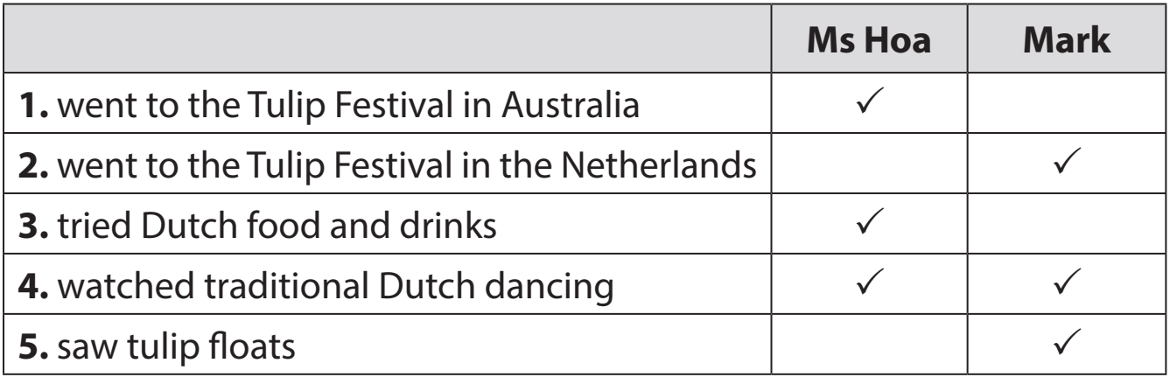

**Act 3: Write a word or phrase from the box under each picture. (ex 3, p. 93)**

**Game: Who is faster?**

* Teacher divides the class into 2 teams. Each team sends a leader to play the game on the board.

- Teacher explains the instructions of the game:

- Teacher gives each team a set of cards with words/phrases from the box.

The two leaders of the teams come to the board and pin the cards under the correct pictures.

Who can finish faster with more correct answers will be the winner.

- Students play the games in teams.

- Teacher has students write down the correct answer.

- Teacher confirms the answers and gives feedback. Teacher can ask for translation to check their understanding.

**Answer key:**

1. parade 2. costumes 3. feast 4. float 5. fireworks display 6. folk dance

**Act 4: Fill in each blank with a word or phrase from 3. you may have to change the form of the word or phrase. (ex 4, p. 93)**

- Teacher asks students to work individually to complete the task. Remind them to change the form of the words/phrases if needed.

- Students fill in the blanks with the most suitable form of word/ phrase.

- Teacher allows students to share answers before discussing as a class.

- Teacher can ask for translation to check their understanding.

**Answer key:**

1. folk dances 2. fireworks display 3. feast 4. parades 5. floats; costumes

IV. POST – STAGE:

Aim: To check Ss’ knowledge of some familiar festivals..

**Act 5: Quiz. what festival is it? match each description with a festival. (p. 93)**

- Teacher lets Ss work in groups of 4-6.

- Ss work in groups to find the answers.

- Teacher can go around to help weaker students.

- Teacher calls the first group to come up with the answers to share.

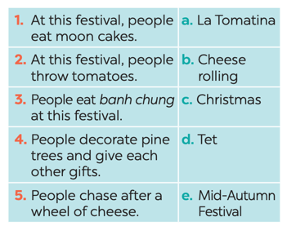

**Answer key:**

1. e 2. a 3. d 4. c 5. B

**V. WRAP-UP:** Teacher asks students to talk about what they have learnt in the lesson.

**VI. HOMEWORK:**

- Learn by heart the new words, read the dialogue again

- Prepare for the next lesson: A closer look 1

* **FEEDBACK:** …………………………………………………………………………………………………………………………………………………………………………………………………………………………………………………………………………………………………………………………………………………………………………………………………………………………………………

|  |  |  |
| --- | --- | --- |
| **Week: 24**  **Period: 71** | **UNIT 9: FESTIVALS AROUND THE WORLD**  **Lesson 2: A CLOSER LOOK 1 / P.94** | **PD: 01/03/24** |

**A. OBJECTIVES:** By the end of this lesson, Ss will be able to gain:

**I. Knowledge:**

- Vocabulary: types of festivals and festival activities

- Pronunciation: pronounce two-syllable words with correct stress

**II. Competences**

- Develop communication skills and creativity

- Be collaborative and supportive in pair work and teamwork

- Actively join in class activities

**III. Qualities**

- Develop self-study skills

- Be interested in festivals around the world.

**B. TEACHING AIDS:**

The lesson plan, textbooks, laptop, TV,…

**C. PROCEDURE:**

I. **Warm – up:**

**Aim: To review the previous lesson and activate students’ knowledge and lead into the new lesson.**

**Game: HOT SEAT**

-Teacher divides the class into 2 teams. Each team will send a leader to play the game on the board.

- Teacher explains the instructions of the game:

- Each leader stands against the board.

- Teacher shows/ writes the names of the festivals (exercise 5 – page 93). Other members from each team describe the festivals and let the leader guess the names of the festivals.

The team with more correct answers is the winner.

- Students play in teams.

- Students give the correct answers.

**II. PRE-STAGE:**

**Aim: -To teach Ss some words related to festivals.**

* **To present some types of festivals**

**VOCABULARY:( Using Pictures,** the definitions/ examples of the wordsto teach Vocab.)

1. Cannes Film Festival: (n) /kæn fɪlm festɪvl/ Liên hoan phim Cannes

2. Mid-Autumn Festival: (n) /mɪd-ɔːtəm festɪvl/ Tết Trung thu

3. Thanksgiving (n) /ˌθæŋksˈɡɪvɪŋ/ Lễ Tạ ơn

4. Easter (n) /ˈiːstər/ Lễ Phục sinh

5. carve (v) /kɑːv/ chạm, khắc

6. perform (v) /pəˈfɔːm/ biểu diễn

- Teacher asks students to repeat.

- Teacher uses the “rub out and check” method to check.

**Act 1: Write under each picture a festival name from the box. (Ex 1, p. 94)**

- Teacher has students look at the pictures and asks them if they know the names of the festivals.

- Teacher gets students to do the exercise in individuals.

- Ask them to share their answers in pairs before checking the answers as a class.

- Teacher then encourages students to explain their answers. Correct if necessary.

**Answer key:**

1. Halloween 2. Christmas 3. Mid-Autumn Festival 4. Cannes Film Festival

5. Easter 6. Thanksgiving

**III. DURING - STAGE.**

**Aim:**

**- To present some festival activities.**

**- To give ss further practice with words/phrases related to festivals and festival activities.**

**- To help students identify identify how to pronounce two-syllable words with correct stress.**

**- To help practise pronouncing these words with correct stress.**

**Act 2: Complete the table below with the phrases from the box. (Ex 2, p. 94)**

- Teacher tells Ss that people celebrate festivals with different food and activities.

- Teacher asks them to do the task in groups of four to complete the table.

- Teacher asks students to share their answers with other groups before checking the answers of one group

- Teacher then encourages students to explain their answers. Correct if necessary.

***Answer key:***

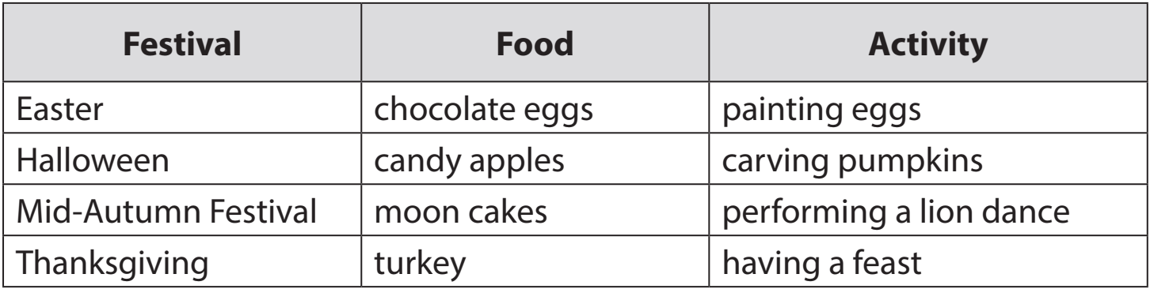

**Act 3: Fill in each blank with a word or phrase from the box. (Ex 3, p. 94)**

-Teacher asks Ss to work in pairs to complete the sentences with the words/ phrases given.

- Ss work in pairs.

- Teacher allows students to cross check first.

- Teacher invites some pairs to share their answers and gives feedback.

**Answer key:**

1. Christmas 2. painting eggs 3. candy apples 4. Cannes Film Festival

5. Mid-Autumn Festival 6. turkey

**PRONUNCIATION:**

**Act 4: Listen and repeat. then underline the stressed syllable in each word.** *(Ex 4, p. 94)*

-Teacher helps Ss to understand what a syllable is. Explain to them that a syllable is a unit of pronunciation having one vowel sound, with or without surrounding consonants, forming the whole part of a word. Give some examples of one-, two- and three-syllable words.

- Tell them that in this lesson, they just focus on two-syllable words and their common stress pattern. Have Ss name some more two-syllable words.

- Teacher has Ss listen and repeat out the words in the table. Play the recording again for them to underline the stressed syllable in each word.

- Teacher allows students to cross check first.

- Teacher lets Ss share their answer and gives feedback. Ask Ss if they recognize any rules related to stress in two-syllable words. Share with them the most common rules

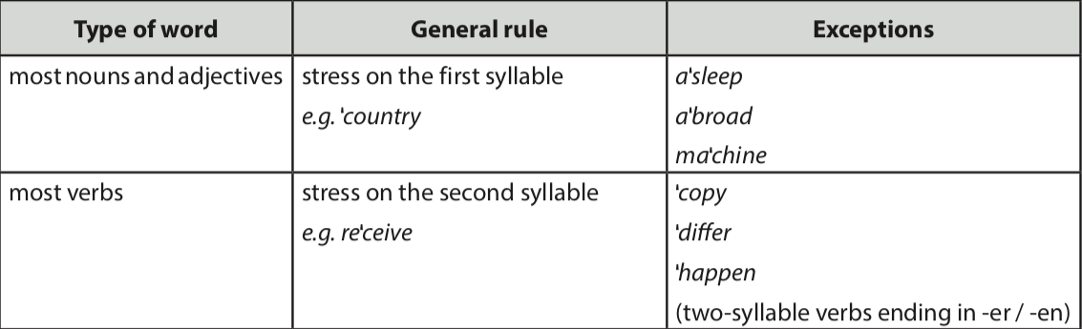.

Answer key:

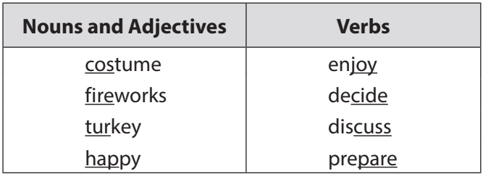

**Act 5: Listen and repeat the sentences. underline the stressed syllables in the bold words.** *(Ex 5, p. 94)*

- Teacher has Ss read the sentences quickly and plays the recording. Ask them to pay attention to the bold words and underline the stressed syllables.

- Students practise in pairs or in groups.

- Teacher goes around offering help or correcting pronunciation, if necessary.

- Teacher calls some students to say the sentences in front of the class. Correcr their pronunciation if necessary.

**Answer key:**

1. We're going to **attend** an Easter **party** at Nick's house.

2. The **dancers** will **perform** traditional dances at the festival.

3. At **Christmas**, people usually buy **presents** for their family.

4. Did you go to the Da Lat **Flower**Festival with your **parents**?

5. My aunt is **clever** and **patient**.

IV. POST–STAGE:

**Aim: To help Ss practice talking about festivals and festival activities :**

**Act 6:** Using the words or phrases **in 1,2 and 3 to** ask and answer the questionsabout the festivals andfestival activities as the sample:

A: What’s your favourite festival ?

B: I like **Christmas**

A: What do people do at **Christmas**?

B: They **give gifts to each other**

`- T asks students to work in groups of four, ask and answer the questions.

- Students work in groups and T goes around to help them if necessary.

- Teacher call some groups to present then gives Ss feedback.

V. WRAP-UP: Teacher asks students to talk about what they have learnt in the lesson.

**VI. HOMEWORK**:

- Do exercises 1,2, P67; 2, 3 .P68 (Workbook)

- Prepare for the next lesson: A closer look 2

* **FEEDBACK:** ………………………………………………………………………………………………………………………………………………………………………………………………………………………………………………………………………………………………………………………………

|  |  |  |
| --- | --- | --- |
| **Week : 24**  **Period: 72** | **UNIT 9: FESTIVALS AROUND THE WORLD**  **Lesson 3: A CLOSER LOOK 2 / P.95** | **PD: 02/03//24** |

**A. OBJECTIVES:**

**I. Knowledge:** By the end of the lesson, students will be able to know how to use Yes/ No questions correctly.

**II. Competences:**

- Develop communication skills and creativity

- Be collaborative and supportive in pair work and teamwork

- Actively join in class activities

**III.** **Qualities:**

- Be interested in festivals around the world.

**B. TEACHING AIDS:**

The lesson plan, textbooks, laptop, TV,…

**C. PROCEDURE:**

**I. WARM – UP:**

**Aim: -*To create an active atmosphere in the class before the lesson;***

***- To lead into the new lesson.***

Game: Sentence puzzling

Teacher divides the class into 4 groups.

* Teacher delivers different sets of word cards to each group.
* Each group has to arrange the word cards to make meaningful sentences.
* 1 point for each correct answer.

** Students play the game in groups.

*** Teacher and students discuss the answers.

**** Teacher confirms the answers and gives feedback.

***Set 1****: Are you eating moon cakes?*

***Set 2****:Did they eat moon cakes at the festival last year?*

***Set 3****:Can he eat all these moon cakes?*

*\** Teacher introduces the target of the lesson: *Yes/No* questions.

**II. PRE-STAGE:**

**Aim:**

***- To help students revise the use of Yes/No questions.***

*- To provide practice with Yes/No questions.*

***- To help Ss pracise making Yes/No questions.***

***- To give further practice with Yes/No questions.***

- Have Ss read the Grammar box in the book

- Teacher draw students’ attention to the use and how to form a *Yes/No* question with an auxiliary verb or with a modal verb.

**GRAMMAR: Yes/No questions**

1. **Form**:

**a/ With ‘tobe’: am/is/are; was/were**

Tobe + S + ……?- Yes, S + tobe / - No, S + tobe + not

**Ex**: *Are you tired now?* – Yes, I am./ No, I am not.

**b/With auxiliary verbs:**

Do/ Does/ Did + S +V(inf) ?- Yes, S + do/does/did/ - No, S + do/does/did + not.

**Ex**: Did you sleep well yesterday?- Yes, I did / No, I didn’t.

**c/ With modal verbs:**Can + S + V(inf)? - Yes, S + can./ No, S + can’t.

**Ex**: Can you swim? – Yes, I can/ No, I can’t.

1. Meaning*: Yes / No* questions are used to check information or ask for confirmation.

**Act 1: Fill in each blank with a correct auxiliary verb or modal verb. (ex 1, p. 95)**

- Ask Ss to do the exercise individually and then check their answers in pairs.

- Invite some Ss to share their answer.

*Answer key:* 1 – Do 2 – Did 3 – Are 4 – Can 5 – Does

**Act 2:** Change the sentences into Yes/No questions.

- Have Ss do this exercise individually then compare the answers with a partner.

- Ask some Ss to wrtite their answer on the board.

- Check the answers with the whole class. Confirm the correct answers.

***Answer key***

1. Can your mother make a costume for you?
2. Will she bake a birthday cake for him?
3. Are the dragon dances interesting?
4. Does the Rio Carnival take place every year in Brazil?
5. Did they see a fireworks display on New Year’s Eve?

**Act 3:** Match the questions in column A with their answer in column B.

- Have Ss do this exercise in pairs and then compare their answers with another pair.

- Invite some pairs to read aloud their answers. Confirm the correct answers.

***Answer key: 1. c*** 2. a 3. e 4. b 5. d

Act 4: Mark is talking to Trang about the Mid-Auturm Festival. Fill in the blanks with Trang’s answer below.

**Game: Who is faster?**

* Teacher divides the class into 2 teams. Each team will send a leader to play the game on the board.

* Teacher explains the instructions of the game:
* Teacher gives each team a set of cards with phrases from the box.
* The two leaders of the teams come to the board and pin the cards under the correct number.
* Who can finish faster with the correct answer will be the winner.

- Students play the games in team mode.

- Teacher has students to write down the correct answer.

- Teacher confirms the answers and gives feedback. Teacher can ask for translation to check their understanding.

*Answer key:* 1. b 2. e 3. a 4. c 5. d

III. POST –STAGE:

Aim: *To help Ss practice producing Yes/No questions.*

Act 5: Game Festival mystery

- Divide Ss into groups. Assign a group leader.

- One student thinks of a festival he/she likes. Other Ss ask Yes/No questions to find out what the festival is.

- The group leader keeps a record of the group’s performance.   
- Move around to observe, paying attention to Ss’ Yes/No questions.

- Invite some group leaders to report what festival his/her group has talked about.  
- Ask some groups to perform in front of the class.

***Example***:

*A: Do many countries celebrate the festival?*

*B: Yes, they do.*

*A: Do children like the festival?*

*B: Do they paint eggs?*

*A: Yes, they do.*

*C: Is it Easter?*

*B: Yes, it is.*

IV. WRAP-UP: Teacher asks students to talk about what they have learnt in the lesson.

**VI. HOMEWORK:**

- Do exercises 4.P67; 5.P68 (Workbook)

- Prepare for the next lesson: Communication

* **FEEDBACK:** ……………………………………………………………………………………………………………………………………………………………………………………………………………………………………………………………………………………………………………………………………………………………………………………………………………………………………………………………………………………………..