Week 24: Date: March, 3rd , 2024
UNIT 9: ENGLISH IN THE WORLD
Period 70 - Lesson 2: A closer look 1
A. OBJECTIVE: By the end of the lesson, students can:
- Use lexical items related to languages and language use and learning
- Identify the correct tones for new and known information and say sentences with the correct intonation
1. Knowledge:
- Vocabulary: Languages and language use and learning
- Pronunciation: Tones in new and known information.
2. Skills:
- speaking, doing exercises.
3. Attitudes:
- SS are encouraged to love the subject more and like to find information about English language.
- Use right tones in speaking.
4. Competences:
- Use lexical items related to languages and language use and learning
- Identify the correct tones for new and known information and say sentences with the correct intonation
B. TEACHING METHODS: Communicative approach, teaching methods by practising, pair work, individual work.
C. PREPARATION:
1. Teacher: book, planning, picture, laptop, projector
2. Students: books, notebooks
D. PROCEDURE:
I. Class organization. - Greetings. - Checking attendance
II. Check up
III. New lesson:
1. Warmer
The whole class play the game: Guessing worlds.
Topic: Languages and language learning:
Words on the board: Dialect, translate, accent, official language, mother tongue, variety, fluenttly.

Ss and teacher’s activities | Content
2. . Presentation:  Vocabulary:  Rub out and remember  3. Practice  - Activity1:Ss work independently and them share their answers with a parther. T may ask for translation of the words/phrases in the first column to check their understanding.  - Activity 2a. Ss do the exercise individually. Check their answers as a class. Confirm the correct a answers.  - Activity 2b. Ss write sentences with the phrases from 2a. Ask some Ss to say their sentences in front of the class. Other Ss give comments. If time allows, call on two Ss to write their sentences on the board. Other Ss gve comments. Confirm the correct sentences.  - Activity 3a. First, have Ss work individually to match the words/phrases. Then allow them to have their answers before checking with the whole class. T may ask for translation of the phrases in the box to check their understanding.  - Activity b. Ss work independently to complete the passage. Check the answers as a lass.  4. Pronuncitation  Tone in new and known information  - Activity 4. Play the recording and ask Ss to listen and repeat the sentences, playing attention to whether the voice on the underlined word in each sentence goes up tor down. T may play the recording as many times as necessary. Explain the ruke in the REMEMBER! box and ask some Ss to give some more examples.  - Activity 5. Play the recording and ask Ss to the conversation, paying attention to whether the voice of each second sentence goes up or down. Ask some Ss to give their answers and then play the recording again for Ss to listen, check and' repeat. T may play the recording as many times as necessary.  - Activity 6. First, ask Ss to work in pairs to practise reading aloud the conversation and identify whether the voice on the underlined word in each sentence goes up or down. Then play the recording. Ss listen and draw suitable arrows. T may pause afer each sentence and ask them to repereat chorally. Correct their pronunciation if necessary. | Voc  - Bilingual /ˌbaɪˈlɪŋɡwəl/ : người nói được hai ngôn ngữ  -Pick up (a language): học ngôn ngữ theo cách tự nhiên từ môi trường xung quanh  - Get by in (a language) : cố gắng sử dụng được 1 ngôn ngữ với những gì mình có  1. Match the words/phrases in column A with the definitions in column B.  Key:1.b 2.e 3. a 4. d 5. f 6. c  2. a. Choose the correct words in the following phrases about language learning.  Key:2. at 3. by 4. in 5. of 6. bit 7. up  2b. Choose the phrases from 2a to make sentences about yourself or people you know.  3a. Match the words/phrases in column A with the words/phrases in column Bto make expressions about language learning..  Key:1.e 2. h 3. g 4. b 5. a 6. c 7. d 8.f  3b. Fill in the blanks with the verbs in the box.  Key:  1.know 2. guess  3. look up 4. have  5. initata 6. make  7. correct 8. translate  Pronuncitation  4. Listen and repeat, paying attention to the tones of the underlined words in each conversation.  Remember:  In conversation, we often refer to something which has been mentioned before. This is known information, and the voice usually goes up at the end. We also tell the listener things we havenot mentioned before. This is new information and the voice usually goes down at the end.  5. Listen to the conversations. Do you tkink the voice goes up or down at the end of each second sentence? Draw a suitable arrow at the end of each line.  Look out: When we are referring to something in the conversation, we do not have to repeat exactly the same words. In this conversation, the voice goes up on the words/phrases that are replaced.  6. Read the conversation. Does the voice go upor down on the underlined words? Draw a suitable arrow at the end of each line. Then listen, check and repeat.  Ss work in pairs to mark the arrow  - listen, check and repeat

IV-Consolidation Vocabulary and tones in statements used as questions
Recall some compound nouns.
V. Homework
- Write new words then learn them by heart.
- Copy the exercise into notebooks.
- Prepare A CLOSER LOOK 2

Date: March, 3rd , 2024
UNIT 9: ENGLISH IN THE WORLD
Period 71 - Lesson 3: A closer look 2
A. OBJECTIVE: By the end of the lesson, students will be able to use:
- Conditionals type 2: review
- Relative clauses correctly and appropriately
1. Knowledge: - Grammar:Conditionals type 2, Relative clauses correctly and appropriately
- Vocabulary: words related to learning English
2. Skills: Practicing skills
3. Attitude: - Ss are interested in using Conditionals type 2 and Relative clauses correctly and appropriately
- Positive about a global language.
- Students know how to learn English in right way.
- Ss are interested in doing exercises.
- Ss are interested in English as a global language and experiences in learning and using English
- Ss are interested in using Conditionals type 2 and Relative clauses correctly and appropriately
4. Competences:
- Co-operation
- Self- study
- Using language to do exercises
- Using language to talk about English as a global language and experiences in learning and using English.
B. TEACHING METHODS: Communicative approach, teaching methods by practising, work individually, work in pairs.
C. PREPARATION:
1. Teacher: book, planning, picture, laptop, projector
2. Students: books, notebooks
D. PROCEDURE:
I. Class organization. – Greeting
- Checking attendance
II. Check up write compound nouns
III. New lesson:
Teacher’s and students’activities  -1. Warm up : Check up old lesson | Content  - Ss - T
2. Presentation  Grammar 1  Conditional sentences type2: review  Grammar 2: Relative pronouns  3. Practice:  Activity 1a:  Ask Ss to study part of the conversation. Draw Ss' attention to how conditional sentences type 2 are formed and used by analyzing the underlined part of the sentence. Draw Ss' attention to the notes and the example s in the Lookout!box. Them ask some more able Ss to give some example to illustrate.  Activity1b. Firts, have Ss work independently, then ask them to share their answers with one or more partners.Ask some Ss to say their answers aloud. Give comments, and make any correction if necessary.  Activity 2. Have Ss work independently to write the sentences.If there isn't much time or Ss are not so strong, allocate one or two sentence per student. Then ask them to share their answers with a partner. Ask some Ss to write their sentences on the board and discuss as a class. Give comments and make any corrections  Relative clauses  Activity 3b. Ask Ss to study the rules in the grammar box. Draw Ss' attention to the use of relative clauses by analyzing the examples in the grammar box in 3b. Then ask the more able Ss to give some further example.  Activity 4. Ask Ss to do the grammar exercise individually. Remind them to look back to the REMEMBER!box and the box in 3b. Then have Ss compare their answers in pairs be fore checking with the whole class.  Activity 5. Have Ss work independently, writing true sentences about themselves. Then ask them to share their sentences with one or more partners to find out how many things they have in common. Ask some Ss to say their sentences aloud. Give comments, and make any corrections if needed. If time allows., have some Ss write their sentences on the board before checking as a class.  Activity 6. Before allowing Ss to do exercise6 ask them to study the rulles in the look out!. Then have Sswork independently. Ask them to share their answers with a partner. Ask some Ss to say their answers aloud. Give comments and make any corrections. | Grammar 1: Conditional sentences type2  If + S + Vpast…, S + would + V  Grammar 2: Relative pronouns  which (for things and animals)  who (for people)  whom (for people as the object of the relative clause)  when (for time)  where (for places)  why (for reasons)  whose (for possession)  that (for people, things, animals and times)  Task 1b.Write Yes or No:  1. No 2. Yes 3. No 4. No 5. No  Task2. Rewrite the sentences  1. If my English were/was good, I would feel confident at interviews
2. If Minh had time, she would read a lot of English books
3. If I were you, Iwould spend more time improving my pronunciation
4. If Mai didn't have friends who were /are native speakers of English, she wouldn’t be so good at the language
5. If you could speak English, we would offer you the job.

Task 3. Circle the correct word. Sometimes more than one answer is possible
Key:1. Who/that 2. Where
3. Whose 4. When/that
5. Whom/who 6. Why

Task 4 -Key:
2. Parts of the palace where/in which the queen lives are open to the public
3. English has borrowed many words which/that come from other languages
4. I moved to a new school where/in which English is taught by native
5. There are several reasons why I don't like English
6. The new girl in our class, whose name is Mi, is reasonably good at English
Task 5 Write true sentences about yourself. Then share them with your partner. How many things do you have in common?
I would like to:
have a friend who …
go to a country where…
buy a book which …
meet a person whose…
do something that…
Bài 6 Rewrite these sentences as one sentence using a relative clause.
1. My friend who/that plays the guitar has just released a CD.
2. Parts of the palace where/in which the queen lives are open to the public.
3. English has borrowed many words which/that come from other languages.
4. I moved to a new school where/in which English is taught by native teachers.
5. There are several reasons why I don’t like English.
6. The new girl in our class, whose name is Mi, is reasonably good at English.

4.Production:  ? Retell conditional type 2 and relative clause | - Answer teacher's questions.
IV-Consolidation Conditional type 2 and relative clause
V. Homework
? Learn by heart all the structures
? Do exercises in Work book
? Prepare: Unit 9: Communication

Date: March, 4th , 2024
UNIT 9: ENGLISH IN THE WORLD
Period 72- Lesson 4: Communication
A./. OBJECTIVE: By the end of the lesson, Ss will be able to how to interview to build up an English learner profile
1.Knowledge: - Vocabulary: words related to languages and language use and learning. - Grammar: Conditional sentence type 2: Review; Relative pronouns.
2. Skills: Practicing skills
3. Attitude: - Positive about a global language.
- Students know how to learn English in right way.
- Ss are interested in doing exercises.
- Ss are interested in English as a global language and experiences in learning and using English
- Ss are interested in usingConditionals type 2 and Relative clauses correctly and appropriately
4. Competences:
- Co-operation
- Self- study
- Using language to do exercises
- Using language to talk about English as a global language and experiences in learning and using English
B. TEACHING METHODS: Communicative approach, teaching methods by practising, work individually, work in pairs.
C. PREPARATION:
1. Teacher: book, planning, picture, laptop, projector
2. Students: books, notebooks
D. PROCEDURE:
I. Class organization. - Greetings. - Checking attendance
II. Check up write compound nouns
III. New lesson:
Teacher& Students’ activities | Content
1. Warmer: Work in groups to discuss the questions:  -What do you think are the best ways top master English?" and " What are the things that you like and don't like about the English language?" elicit Ss' answer.  2. Pre speaking:  3. While- speaking  Activity 1. Give Ss about 10 minutes to work independently, making notes about themsevels by answering the questions in the table in 1  Activity2. Work in pairs. Take turns to ask and answer the questions in 1. Make notes about your partner. How many things do you have in common?  4. Post speaking  Activity 3. Work in groups. Tell your group the things that you and your partner have in common.  Now put two pairs together to work in groups of four, reporting on the things that they and their partners have in common. T moves around the class to the discussions and provide help only if necessary. | Task 1. Make notes about yourself:  1. I have been learning English for 7 years  2. It was the first time I have studied English so I found it very joyful when I study English.  3.Final exams  4. Because I can read my favorite books in English.  5. I would like to go to USA  6. I think I reach to medium level.  7. I listen to English music everyday  8. I use English to travel and find a suitable job.  9. It is easy than other languages  10. It has a lot of grammars that I find they are hard to remember.  Task 2: Work in pairs. Take turns to ask and answer the questions in 1. Make notes about your partner. How many things do you have in common?  Task 3: Work in groups. Tell your group the things that you and your partner have in common.  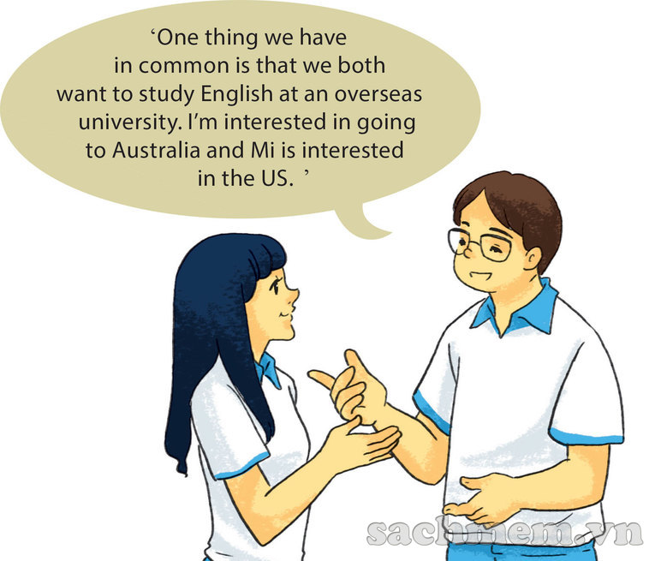

IV-Consolidation: - Review this lesson
V. Homework - Copy the exercise into notebooks.
- Prepare SKILLS 1

Feedback:……………………………………………………………………………………………………………………………………………………………………………………………………………………………………………………………

